**ST. JANAN LUWUM SECONDARY SCHOOL**

**END OF TERM ONE GEOGRAPHY EXAMINATION**

**S.1**

**Instructions.**

**Answer all items in this paper**

**TIME. 2 HOUR**

**Item1**

The geography in the places where we live is composed of many living and non-living things big and small all of them important to us. In our interaction with the environment, sometimes the activities we do cause harm tom to environment. When the environment is destroyed, our existence is also threatened. There is great need to protect bit for our survival.

**Support material**.

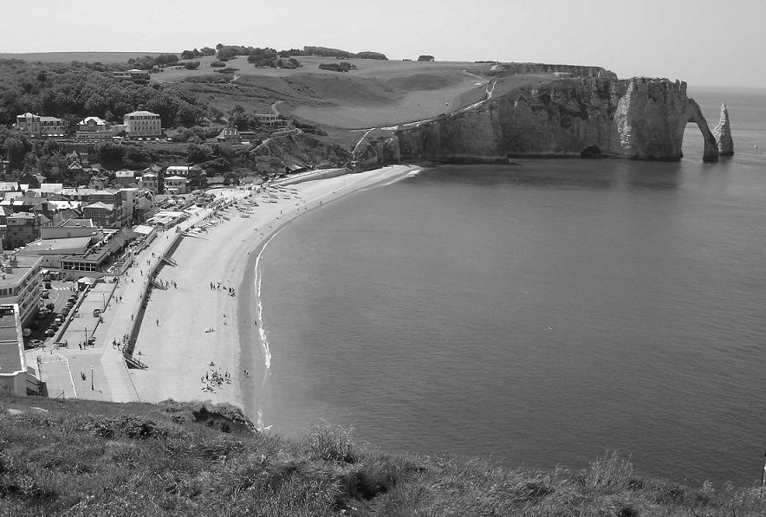

Fig. 1

**Support material: study the Word puzzle bellow to help you do the following tasks..**

|  |  |  |  |  |  |  |  |  |
| --- | --- | --- | --- | --- | --- | --- | --- | --- |
| **V** | **A** | **L** | **L** | **E** | **Y** | **D** | **C** | **E** |
| **M** | **E** | **S** | **V** | **I** | **W** | **F** | **T** | **A** |
| **T** | **E** | **O** | **C** | **U** | **B** | **I** | **O** | **C** |
| **U** | **R** | **I** | **V** | **E** | **R** | **U** | **U** | **L** |
| **C** | **K** | **L** | **T** | **F** | **N** | **A** | **D** | **I** |
| **O** | **L** | **B** | **H** | **I** | **L** | **L** | **E** | **F** |
| **A** | **M** | **U** | **T** | **S** | **E** | **A** | **E** | **F** |
| **S** | **U** | **N** | **I** | **A** | **R** | **I** | **M** | **A** |
| **T** | **D** | **B** | **E** | **A** | **C** | **H** | **N** | **G** |

Fig. 2

**Task:**

1. Study the word puzzle above and write 10 physical features that can be found in an environment (20scores)
2. People in different areas are so much connected to their environment. They obtain food, medicine, recreation, housing materials and many other benefits. Study the support material bellow and show how people in different places make use of their environment.

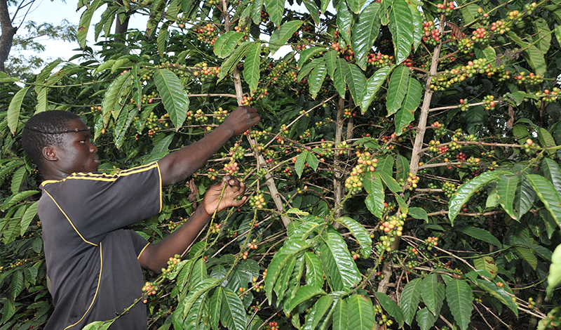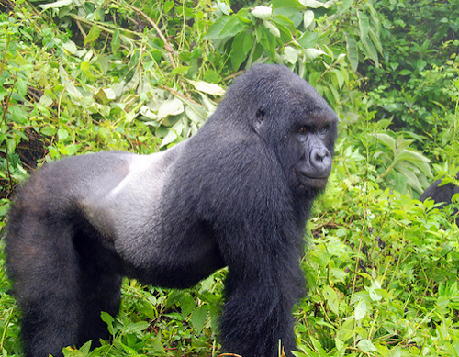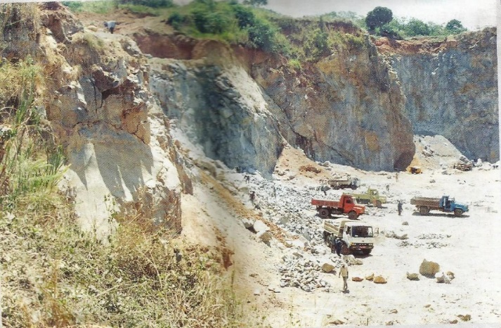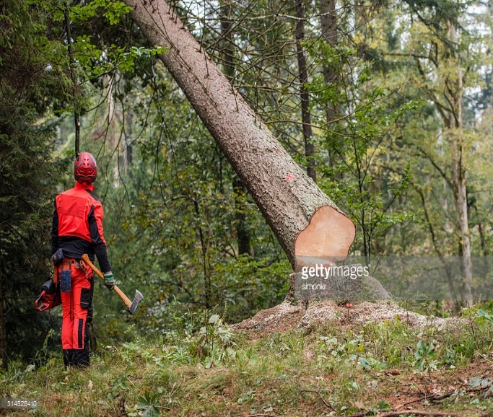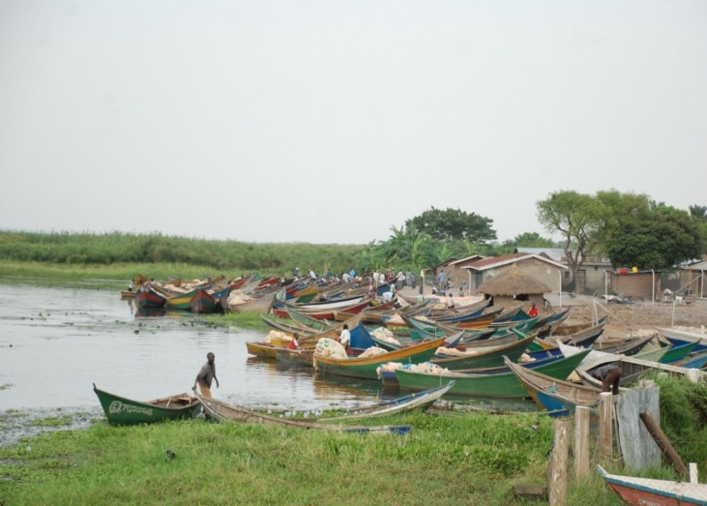

Fig.3

**Task:** write a letter to your friend of note more than 500 words showing how people in the environment shown in the support materials above make use of their environment.

(10scores)

1. Different human activities cause a lot of harm to the environment. The vegetation, animals, water resources, air and land are all always get affected as man use them carelessly.

Study the photographs bellow to show how the activities shown harm the natural environment.

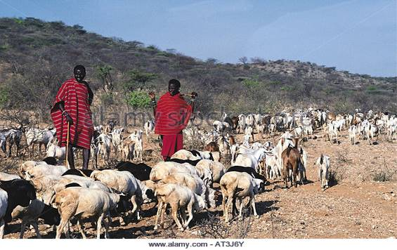

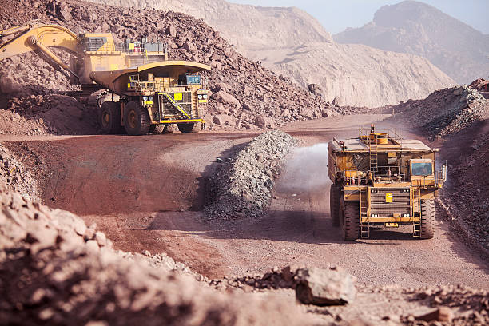

Fig4

Your father is the LC1 chairperson of your home area where the activities seen in figure 4 above are practiced. Everyone is concerned since they cause great harm to the environment. Imagine you a local council meeting has been called to discuss the way forward and come up with solutions to those challenges. Prepare some advice you can share with the local people to solve the problems caused by those activities. (10scoress)

**Item2**

The physical features and human-made features in our environment can be represented on the map. That’s why maps are a very important tool in the study of geography. Maps help us get knowledge of features in other places even away from us.

**Support material**

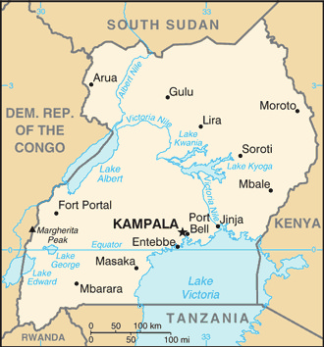

**Tasks**.

1. What do you think the map above is missing to qualify to be a useful map

…………………………………………………………………………………………………………………………….

……………………………………………………………………………………………………………………………

…………………………………………………………………………………………………………………………….

………………………………………………………………………………………………………………………..(8scores)

1. What would be the suitable title for the above map?..............................................

……………………………………………………………………………………………………………………………..

………………………………………………………………………………………………………………………. (2scores)

END